**計算機程式設計HW10report 103061223李俊穎**

1. **Introduction of the problem and your solution**

The homework 10 is a “Small World Network” that we have to investigate the number of links to reach neighbor nodes which are connected randomly. First, we have to generate how many nodes we have in this program. The nodes just like the countries or villages, and they all linked by the road each sides. This homework’s problem is that when these nodes are connected in a ring, how we to calculate the distances from a start node to the farthest node.

Because this time most of the codes have already been given, we just need to translate the hints in the function which given by instructor. Besides, we need to produce the one pair of nodes and add it into the ring at a time. My solution is consider all the condition pairs of nodes. After generating them, I store them into a class, and then push_back the class in a vector named path. So I can add the pair of nodes randomly in the all_nodes neighbor until it finish the for loop. The following is my code:

1. **Implementation details ,Additional features of your program (data structure, flows and algorithms)**

In the first step, I link all the nodes to be a ring:

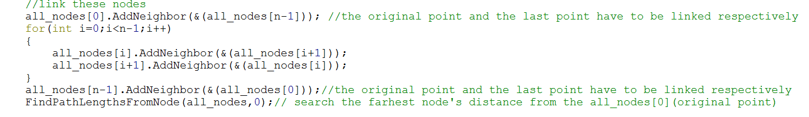

The original point and last point have to link respectively because if we put them in the for loop, the vector of the all_nodes will overflow.

Next, I link all the paths between two nodes in the ring:

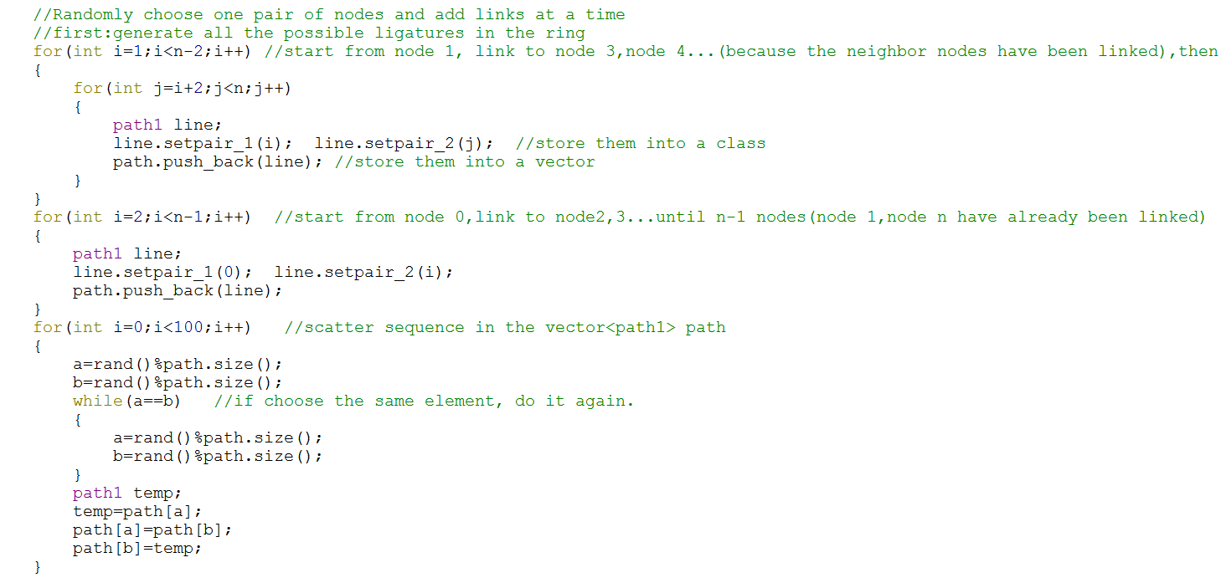

After producing all the paths, store them into the vector with class type, and randomize them.

Third step is as following:

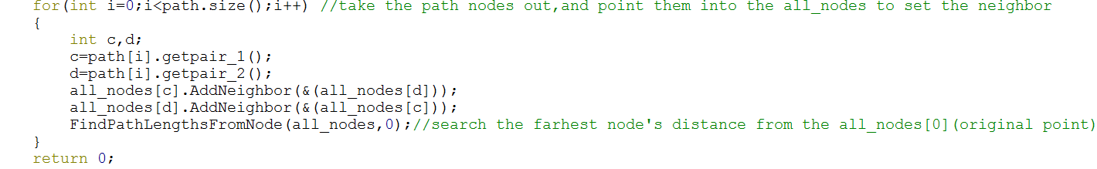

What this step does is add one pair of nodes at a time, and find the farthest path from nodes 0. After running the path.size() times, all the nodes have been linked with each other, so the farthest distance is 1.

The following is the function FindPathLengthsFromNode():

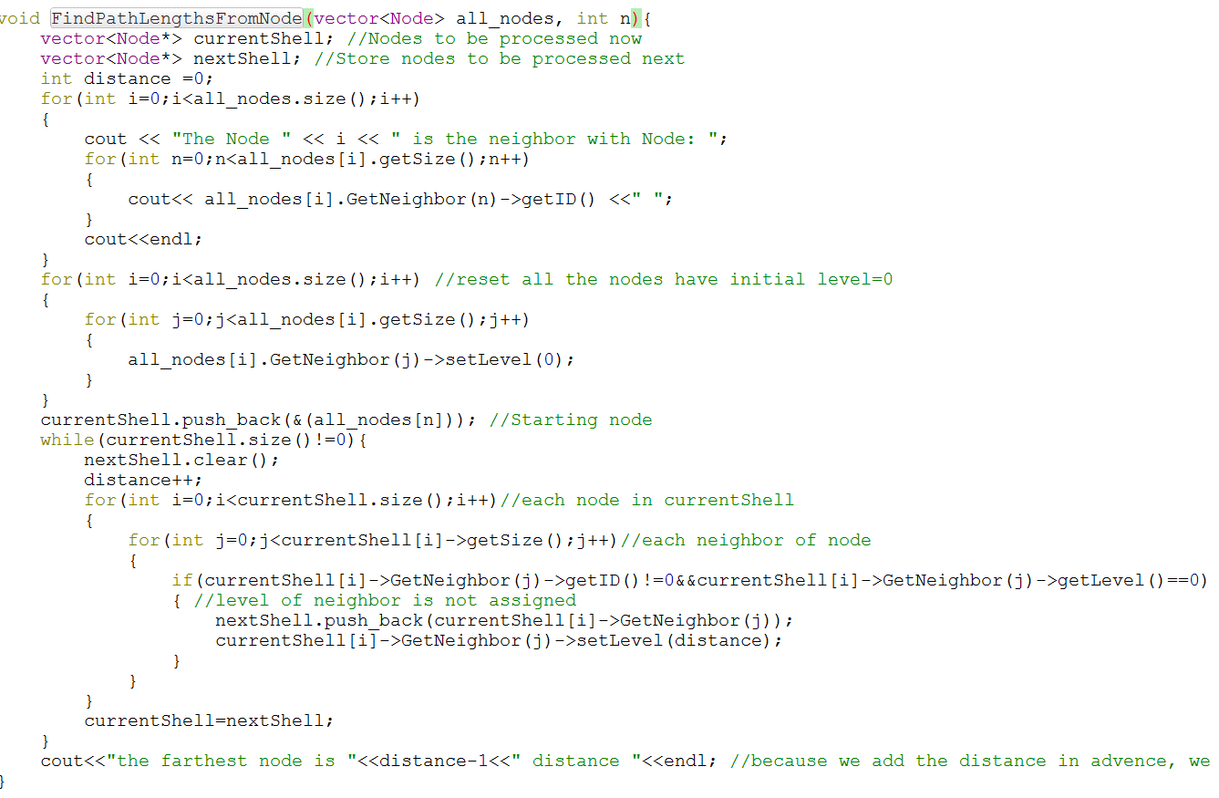

The extra thing I add is seting all the nodes’ level as 0 before the while loop, so every time I can check if this level of neighbor be assigned. If so, set the level with distance and output it, that’s all.